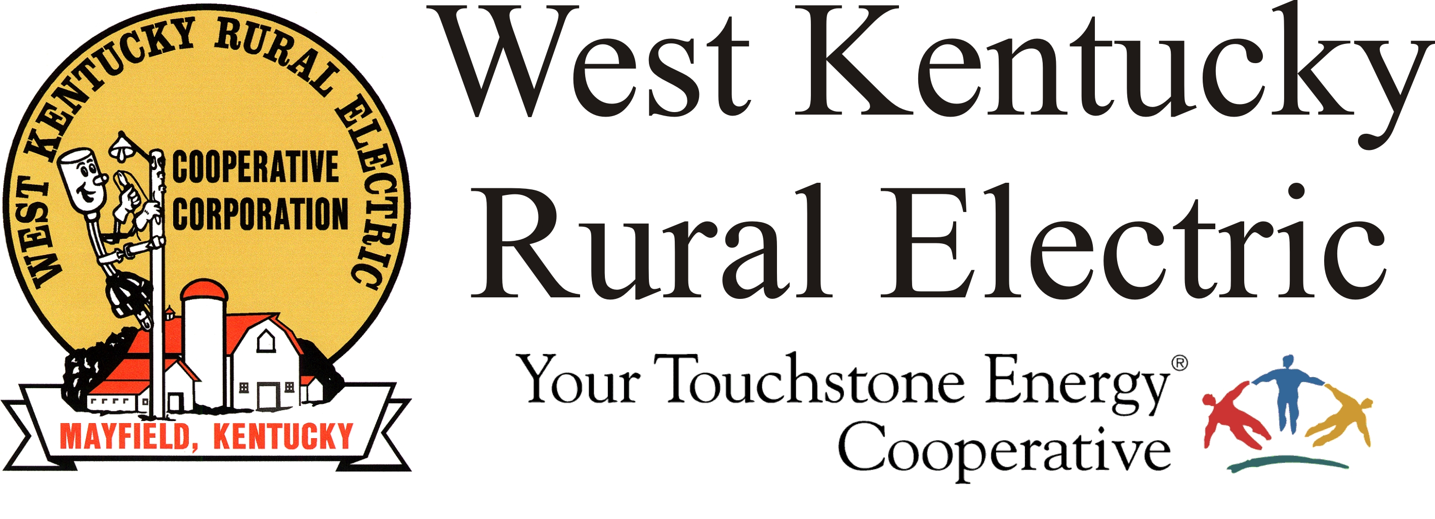

West Kentucky RECC Tuesday Evening
Storm Damage Update

(Mayfield, Ky.) Dec. 14, 2021, 6:15 p.m.) – The number of West Kentucky Rural Electric Cooperative members without service has dropped to 1,096, down from 2,000 earlier today. This is significant progress in spite of many very difficult repairs.
The WKRECC website is back in service at its usual address, www.wkrecc.com. Online bill-pay and other automated services are operational. Approximately 80% of our operational communications network has been restored and we expect to see further progress overnight. This supports our ability to accurately monitor the distribution system and retrieve the data necessary for member tools such as MyPower.
The Murray and Benton business offices will be open daily from 7:30 a.m. to 4:00 p.m. The Mayfield office will remain closed, however, members are encouraged to use the night deposit. We are processing payments daily.
To report an outage, call 1-877-495-7322 and use option 1 to leave a recorded message.
Reminders:
- Please do not pile debris beneath the power lines. Doing so impedes access to the poles and lines and slows repair work.
- Be alert for scams. Today several WKRECC members were called by scammers trying to take advantage of the disruptions caused by the tornado to steal money and personal information. Don’t be a victim! If a caller make threats about your electric service, just hang up.
- Disconnects for non-payment are temporarily suspended. We will announce when disconnects resume.
___________________________________________________________

Georgann Lookofsky, 270-804-1701 or glookofsky@wkrecc.com

